# Email Templates

Email a link to your new blog post to reinforce your connections’ awareness of you. The goal is to get them to click on the link to your blog post, but the email itself also shares just enough quality information that readers will get an instant good impression of your business expertise.

Customize the following email template with your information and blog post link. [See how to send the email in this help article.](https://thepaperlessagent.freshdesk.com/support/solutions/articles/14000092297-sharing-the-monthly-value-program-via-email)

*NOTE****:***If this is your first time sending out an email campaign or you’re not sure that your contact will remember you, use the Reengagement Letter Email Template instead (below).

**February 2025 Email Template**

**SUBJECT**: Maximize Your Home’s Value with These High-ROI Remodeling Projects!

Hi {first_name},

Are you looking to boost your home’s value? If so, it’s important to know which remodeling projects will give you the highest return on investment (ROI).

I’ve just published a blog post highlighting the top 3 home remodeling projects that deliver the best ROI, and you might be surprised by what made the list!

Here’s a quick overview:

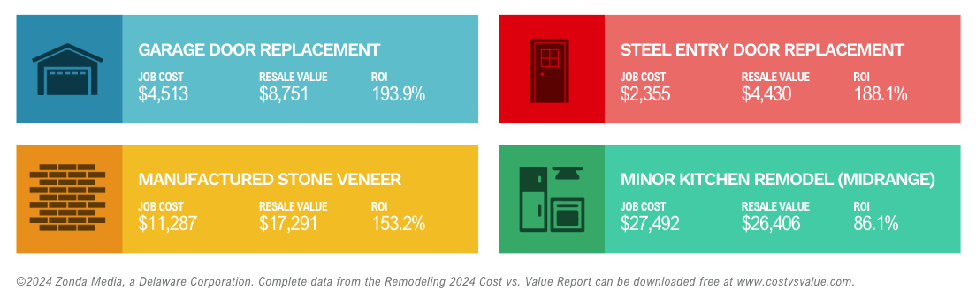

1. **Garage Door Replacement***Job Cost:* $4,513  
   *Resale Value:* $8,751  
   *ROI:* 193.9%  
   Replacing an old garage door can dramatically increase your home’s curb appeal—and it’s the most cost-effective way to boost your home’s value.
2. **Steel Entry Door Replacement***Job Cost:* $2,355  
   *Resale Value:* $4,430  
   *ROI:* 188.1%  
   Not only does a steel entry door enhance security, but it also gives your home a modern, high-end look while improving energy efficiency.
3. **Manufactured Stone Veneer***Job Cost:* $11,287  
   *Resale Value:* $17,291  
   *ROI:* 153.2%  
   Adding manufactured stone veneer to your home’s exterior gives it a sophisticated, upscale look without the heavy price tag of real stone.

These projects offer huge returns for relatively small investments—perfect for homeowners looking to sell in a competitive market.

If you’re curious how to increase your home’s value, this article will give you all the information you need to make the right decisions.

[**Read the Full Blog Post Now**]

If you’d like to talk more about how these renovations can impact your home’s value or get specific advice about the local market, I’d be happy to help. Feel free to reach out!

To your success,

[signature]

P.S. Don’t miss out on these high-ROI remodeling tips to maximize your home’s value. Click here to read more: [**Read the Full Blog Post**].

*Note: For maximum effectiveness, the Reengagement Email should be sent from an individual, rather than a team, email.*

**Reengagement Letter Email Template**

**Subject***:* My apologies…

Hi {first_name},

You deserve an apology from me.

I haven’t stayed in good contact with you (this is entirely my fault).

Recently, I’ve decided to rededicate myself to taking better care of the people I want to serve — like you!

**“What does this have to do with me?”** you might be asking.

Great question!

In order to better serve you, I’m going to stay in touch and work to provide you with greater value.

My first order of business is to provide you with tools, resources, and real estate tips & advice from time to time.

Here’s my first resource for you…

My latest blog post, titled **“MVPCAMPAIGNTITLE”** → [insert link to blog post]

I hope you find it useful, and I look forward to staying in touch.

[signature]

P.S. I share valuable real estate info like this all the time on my social media. I’d be honored if you would kindly take a moment to follow me. → [insert link to your Facebook or Instagram page]

**Client Activation Email Template**

**Subject Line:** Boost Your Home's Value with These Top 4 Projects!

Hi {First Name},

Did you know some home improvement projects can give you a big return on your investment when it’s time to sell? I just wrote a quick guide on the **Top 4 Home Improvement Projects with the Highest ROI**, and it’s packed with tips to help you make the most of your home’s value.

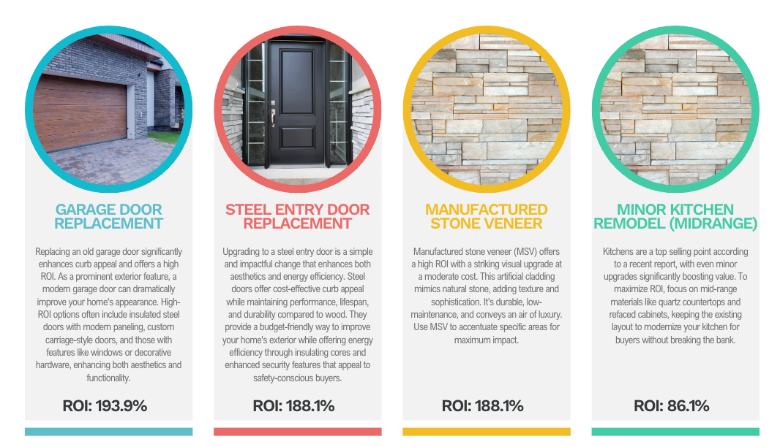

Whether you're looking to sell soon or just want to build equity, these projects are smart moves that can pay off big.

👉 **Read the guide here** [insert link]

Have questions about how these upgrades could impact your home’s value? I’d love to chat about your goals and share how the market is looking in your neighborhood.

Hit reply or book a quick call with me [insert link].

Looking forward to connecting!

[signature]